Sun-Hit Engine — Technical Spec
Oct 9, 2026 · @Bamba Ba

Context and background
This section carries everything decided before the spec was written, so a reader with no prior conversation can build from it.
Origin of the idea. It started with a simple need: know when the sun will hit a balcony so laundry can dry outside. The idea then generalised: for any precise spot on Earth, predict the exact minutes when direct sunlight reaches it, taking into account buildings, trees, terrain and passing clouds. Laundry is one use case among many (balcony solar panels, terraces, gardens, real estate, photography, outdoor events).
Key insight. The problem splits into three layers with different certainty:
- Sun position — pure astronomy, exact for any date, years ahead.
- Obstruction — whether something blocks the sun at that spot; near-exact once the surroundings are known.
- Clouds — probabilistic; minute-level only 0–3 hours ahead (by tracking real clouds on satellite images), hourly probability up to about 3 days, climate statistics beyond.
Clouds never change when the sun can reach a spot, only whether it does.
Market research findings (October 2026).
Player | What it does | What it lacks
Shadowmap (Vienna, about $1.1M raised) | Sun or shade for any spot now or in the future, 3D buildings; API used by Redfin and Willhaben; claims 700k+ monthly users | No cloud forecasting found
Solcast (acquired by DNV in 2023) | Satellite cloud nowcasting every 5–15 min, 1–2 km, downscaled to 90 m; solar irradiance API | No building-level shadows; aimed at solar farms
SunSeekr | Consumer app: sunny terraces by hour, weather factored in, alerts; claims 250k users | Venue-only, hourly, no minute-level nowcast
Terrace apps (Coffee in the Sun, Sunnyspot, Sunseat, Parasol, SunnySide) | Sun or shade on terraces from geometry | No real cloud prediction
Laundry apps (DryCast, Pegs Out, Washcast, Drying Buddy, labais.life) | Drying windows from weather | No shadows or spot geometry
ShadePlot | Notification when a shadow reaches a chosen point | No weather
The gap. Nobody found sells building-level shadows fused with minute-level satellite cloud nowcasting for a precise spot. Each piece exists separately; the fusion and the ground-truth data are the opportunity.
Evaluation against the founder's three filters:
- AI moat — weak for a plain API wrapper, strong with ground truth. All inputs are public, so the defensible asset is the proprietary dataset of real measurements at real spots (sensors, balcony-PV output, user confirmations) that continuously corrects the models.
- Trend — strong. Germany alone had about 1.33 million registered balcony solar systems by May 2026, growing by about 850 a day; solar supplies almost 10% of world electricity.
- Easy exit — strong. Precedent: DNV bought Solcast. Natural acquirers: Shadowmap, Solcast/DNV, weather companies, real-estate portals, balcony-solar brands.
Recommended wedge. Balcony and rooftop solar owners first: every panel is a free sun sensor at a known spot, which builds the ground-truth moat while serving users ("run the washing machine now, your panel covers it"). Real estate, terraces and weather apps come after.
Founder constraints.
- Built by a senior full-stack developer (TypeScript, Node.js, Fastify, BullMQ, Redis, PostgreSQL, Docker, Kubernetes, React / React Native) based in Rome.
- Everything runs in Docker containers.
- Prefer open-source software and open data over third-party APIs wherever possible.
- Top priority: data quality and prediction accuracy, proven against real measurements.
- Starting market: Italy (Rome as the first test city), with the Alps as the next region (open question, see Risks).

Overview
The Sun-Hit Engine answers one question for any surface on Earth: when will direct sunlight reach this exact spot, and how sure are we? It returns minute-level sun windows plus a calibrated probability that the sky will actually be clear in each window.
It is built as self-hosted Docker services on open-source software and open data. Paid third-party APIs are avoided; the edge comes from data quality and from learning against real measurements.
What a spot is. Latitude, longitude, height above ground, and the surface's tilt and facing (a balcony floor, a panel, a terrace table, a window).
What the engine returns for a spot:
- Geometric windows — when the sun is above the local horizon and not blocked by terrain, buildings or trees. Exact, for any date.
- Sky forecast per window — probability of direct sun, minute-level for 0–3 h (satellite nowcast), hourly for 4 h–7 days (weather models).
- Irradiance on the surface — W/m² direct and diffuse, so downstream apps can compute drying speed, PV output or heat.
v1 scope: Italy plus the Alpine region (Switzerland, Austria, southern Germany), REST API, one reference consumer app.
Non-goals for v1: global coverage, indoor light, reflected sunlight off glass facades, rain or wind forecasting beyond what the weather models give.

Prediction model
The prediction is the product of three independent layers: geometry (exact), obstruction (near-exact once calibrated) and sky (probabilistic). Keeping them separate lets each one be validated and improved on its own.
P_{sun}(spot, t) = G(spot, t) \cdot O(spot, t) \cdot T_{veg}(spot, t) \cdot P_{clear}(spot, t)
G is 1 when the sun is above the spot's plane and horizon, O is 1 when no building or terrain blocks the ray, T_veg is the light passing through trees (0 to 1, seasonal), and P_clear is the calibrated probability that no cloud covers the sun's line of sight.

Layer A — Geometry
- Sun azimuth, elevation and refraction from the NREL Solar Position Algorithm via pvlib (Python, BSD).
- The surface's tilt and facing decide whether the sun is in front of it (angle of incidence below 90°).
- Computed on the fly at 1-minute steps; cheap enough that nothing needs caching.

Layer B — Obstruction (the per-spot horizon)
- For each spot, cast rays every 1° of azimuth over a fused surface model (terrain + buildings + trees) and store the highest blocking angle: a 360-value horizon profile.
- Buildings and trees are traced out to 2 km, terrain out to 50 km (mountains matter in Italy and the Alps).
- Trees are stored separately with a seasonal transmissivity: deciduous canopy lets more light through November to April.
- Profiles are computed once per spot and cached; they only change when the user corrects them.
- User calibration overrides the model: an AR sky scan, or a few "sun hit / no sun" taps, corrects the profile for things no dataset sees (awnings, balcony railings, a new building).

Layer C — Sky (where the edge is)
Three horizons, blended into one probability:
Horizon | Source | Step | Method
0–3 h | Satellite nowcast | 10–15 min | Deep-learning cloud motion on Meteosat imagery, with cloud-shadow parallax correction
3 h–3 days | High-res weather models | 1 h | ICON-2I (about 2 km over Italy) and ICON-EU, statistically downscaled
3–7 days | Global models | 1–3 h | ECMWF IFS open data and ICON global, ensemble spread as uncertainty
Parallax correction is critical for minute-level accuracy. A cloud seen above a pixel casts its shadow elsewhere, shifted by cloud height and sun angle. Using the satellite's cloud-top-height product, each cloud is projected along the sun's ray onto the ground before checking the spot.
Blending model. A gradient-boosted model (LightGBM) takes all sources plus the time of day, season and the spot's recent forecast errors. Its target is "direct sun" defined as direct normal irradiance above 120 W/m², the WMO sunshine-duration threshold. Output probabilities are calibrated with isotonic regression so that "70%" really means 7 in 10.
Irradiance output. pvlib transposes forecast direct and diffuse irradiance onto the surface's plane, so apps get W/m² on the actual balcony or panel, not on flat open ground.

Open data sources
Every input is free and open; the only accounts needed are free registrations (EUMETSAT Data Store, Copernicus). No paid forecasting API sits in the critical path.
Layer | Source | Resolution | What it gives us | License / access
Sky 0–3 h | EUMETSAT MTG-I FCI | 16 channels at 1–2 km; 4 channels at 0.5–1 km | Live cloud imagery over Europe and Africa | Free, EUMETSAT Data Store account
Sky 0–3 h | Meteosat SEVIRI | about 3 km, 5–15 min | Training history; still disseminated until at least end 2026 (EUMETSAT) | Free
Sky 0–3 h | Open Climate Fix cloudcasting | 15 min, 3 h ahead | Pretrained cloud-motion models (SimVP, Earthformer, IAM4VP) | MIT
Sky 3 h–3 d | ItaliaMeteo ICON-2I | about 2 km, hourly, 3 days, every 12 h | Cloud cover, radiation, humidity over Italy | Open data
Sky 3 h–7 d | ECMWF IFS open data, DWD ICON-EU / global | 7–25 km | Medium-range sky and ensemble spread | Open data
Sky ingest | Open-Meteo, self-hosted | per model | Downloads and stores all NWP models as a fast time-series DB | AGPL-3.0, Docker
Sky | Copernicus CAMS | about 40 km | Aerosols and ozone for clear-sky irradiance | Free, Copernicus account
Buildings | GlobalBuildingAtlas (TUM) | 3 m height raster; LoD1 models, height RMSE 1.5–8.9 m by continent | Building footprints and heights worldwide | Open
Buildings | OpenStreetMap / national LiDAR where open | varies | Better heights where mapped; LiDAR overrides | ODbL / national licenses
Trees | Meta + WRI canopy height | 1 m | Individual tree heights | Commercial use permitted
Terrain | Copernicus DEM GLO-30 | 30 m | Mountains and hills for the far horizon | Free
Geometry | pvlib (NREL SPA) | exact | Sun position, irradiance transposition | BSD
Ground truth (the moat). Models are only as good as what corrects them, so measurements are collected from day one:
- Balcony and rooftop PV owners — inverter output via local open-source gateways (OpenDTU, Home Assistant). Every panel is a sun sensor at a known spot.
- Own reference sensors — about 20 ESP32 + light-sensor boxes on known balconies in Rome, logging every 10 seconds (cheap, about 25 € each).
- Regional weather stations — pyranometer data from Italian regional ARPA networks where published as open data (to verify region by region).
- User taps — "sun now / no sun now" confirmations from the app, used for horizon calibration and as labels.

System architecture
Sky, weather and surface data are processed in separate lanes and meet only in the predictor; ground truth closes the loop by retraining it every night.
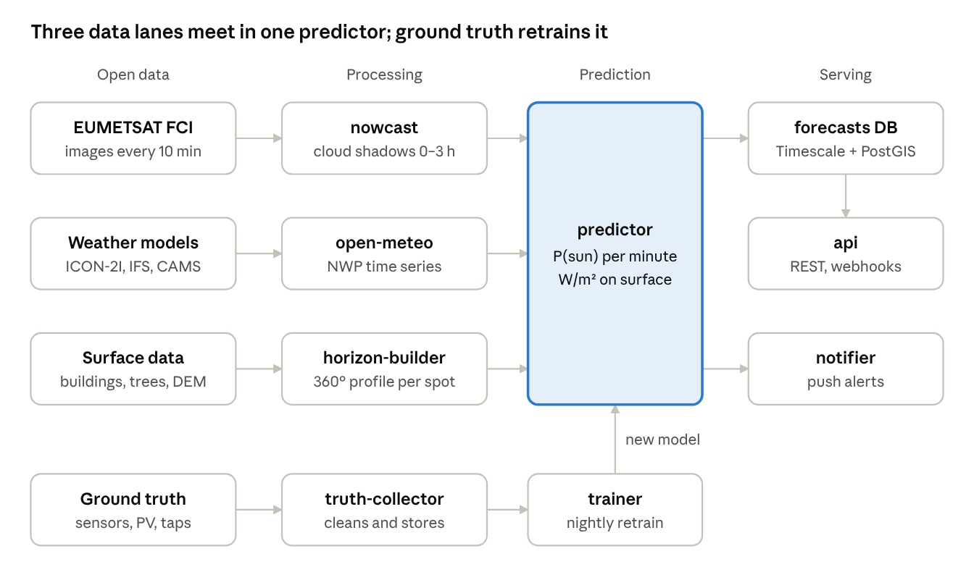
system architecture · 3 data lanes, 1 predictor, 1 learning loop
The lanes run on different clocks: satellite every 10 minutes, weather models twice a day, surface data a few times a year. Decoupling them through storage means a slow lane never blocks a fast one.
The diagram in text (columns left to right: open data → processing → prediction → serving):
Lane | Open data source | Processing service | Feeds into
Sky, 0–3 h | EUMETSAT FCI satellite images, every 10 min | nowcast — cloud motion + cloud-shadow parallax, 0–3 h | predictor
Sky, 3 h–7 days | Weather models: ICON-2I, ECMWF IFS, CAMS | open-meteo — NWP stored as time series | predictor
Surface | Buildings, trees, terrain (DEM) | horizon-builder — 360° horizon profile per spot | predictor
Learning loop | Ground truth: sensors, PV output, user taps | truth-collector — cleans and stores | trainer (nightly retrain) → new model → predictor
Connections:
- predictor (the single fusion point) outputs P(sun) per minute and W/m² on the surface.
- predictor → forecasts DB (TimescaleDB + PostGIS) → api (REST, webhooks).
- predictor → notifier (push alerts).
- Ground truth → truth-collector → trainer → new model back into predictor.
Services never call each other directly: they exchange data through Redis queues, PostgreSQL and MinIO.

Services spec
Twelve containers in two languages: TypeScript for the API and I/O-heavy services (Fastify, BullMQ), Python for anything scientific (pvlib, PyTorch, LightGBM). They talk through Redis queues and shared storage, never directly.
Container | Language / stack | Job | Reads | Writes
api | TypeScript, Fastify | Public REST API, auth, rate limits | Postgres, Redis cache | Jobs to Redis
horizon-builder | Python, GDAL, rasterio, Numba | Ray-casts the 360° horizon profile for new or corrected spots | DSM tiles on MinIO | horizons table
dsm-builder | Python, GDAL, PDAL | Fuses DEM + buildings + canopy into Cloud-Optimized GeoTIFF tiles, rebuilt when sources update | Raw datasets | DSM tiles on MinIO
sat-ingest | Python, eumdac, satpy | Pulls FCI images every 10 min, reprojects, crops to coverage area | EUMETSAT Data Store | Zarr cubes on MinIO
nowcast | Python, PyTorch (GPU) | Runs cloud-motion model, projects cloud shadows with parallax, outputs 0–3 h cloud masks | Zarr cubes | Shadow-mask forecasts on MinIO
open-meteo | Open-Meteo image | Stores and serves ICON-2I, ICON-EU, IFS and CAMS as time series | Open data mirrors | Local volume
predictor | Python, LightGBM, pvlib | For each active spot: geometry + horizon + nowcast + NWP → calibrated P(sun) per minute and W/m² | All of the above | forecasts hypertable
truth-collector | TypeScript, MQTT | Receives sensor, PV-inverter and user-tap data; cleans and stores it | Mosquitto broker, API | observations hypertable
trainer | Python, LightGBM, MLflow | Nightly retraining and recalibration of the blending model; promotes a model only if it beats the current one | forecasts vs observations | Model registry
notifier | TypeScript, BullMQ | "Sun window starts in 15 min" and "cloud coming" alerts via webhooks and push | forecasts | Webhooks, FCM / APNs
scheduler | TypeScript, BullMQ | Cron for ingest, prediction cycles, retraining | — | Jobs to Redis
monitoring | Prometheus, Grafana | Pipeline health, data freshness, live forecast skill | All services | Dashboards, alerts
Shared infrastructure: PostgreSQL 16 with PostGIS (spots, horizons) and TimescaleDB (forecasts, observations); Redis (queues, cache); MinIO (S3-compatible object storage for rasters and image cubes); Mosquitto (MQTT for sensors).
Prediction cycle. Every 10 minutes, when a new satellite image lands: nowcast runs once for the whole region (about 1–2 min on one GPU), then predictor updates all active spots in batches. NWP-only horizons refresh when a new model run arrives (ICON-2I twice a day).

API design
A spot is registered once, then queried many times; registration triggers the horizon computation (about 5–20 s), queries are served from precomputed forecasts in under 100 ms.
Method | Path | Purpose
POST | /v1/spots | Register a spot (location, height, tilt, facing); starts horizon build
GET | /v1/spots/{id}/horizon | The 360° horizon profile, with source per segment (building, tree, terrain, user)
POST | /v1/spots/{id}/calibrate | Submit an AR scan or sun / no-sun taps to correct the horizon
GET | /v1/spots/{id}/windows | Sun windows for a date range, with probability per window
GET | /v1/spots/{id}/timeline | Minute-level P(sun) and W/m² ahead; `hours` parameter, default 72, max 168 (7 days)
POST | /v1/spots/{id}/observations | Push ground truth (sensor reading, PV output, user tap)
POST | /v1/webhooks | Subscribe to window-start, cloud-incoming and window-lost events
GET | /v1/point | Stateless one-off query by lat/lon (no calibration, lower accuracy)
Example GET /v1/spots/sp_8f2c/windows?date=2026-10-10:
{
"spot_id": "sp_8f2c",
"date": "2026-10-10",
"timezone": "Europe/Rome",
"geometric_windows": [
{ "start": "11:42", "end": "15:08", "blocked_after_by": "building" }
],
"sky": [
{ "start": "11:42", "end": "13:20", "p_sun": 0.91, "source": "nowcast" },
{ "start": "13:20", "end": "13:35", "p_sun": 0.18, "source": "nowcast", "reason": "cloud passing" },
{ "start": "13:35", "end": "15:08", "p_sun": 0.84, "source": "nwp_blend" }
],
"expected_sun_minutes": 171,
"peak_irradiance_wm2": 612,
"model_version": "blend-2026-10-09",
"horizon_confidence": "calibrated"
}
Every response carries model_version and horizon_confidence (modelled or calibrated) so clients can show how much to trust it.

Data quality and validation
No model ships unless it beats the current one and two naive baselines on held-out ground truth; every forecast is stored and scored against what actually happened.
Metrics, per layer:
What | Metric | v1 target (to confirm with first data)
Sun-hit start / end time, calibrated spot | Mean absolute error vs sensor, minutes | ≤ 3 min
Sun-hit start / end time, modelled-only spot | Same | ≤ 10 min
P(sun), 0–3 h | Brier skill score vs smart persistence | ≥ 0.20 at +1 h
P(sun), day ahead | Brier skill score vs raw NWP cloud cover | ≥ 0.15
Calibration | Reliability curve, expected calibration error | ≤ 0.03
Irradiance on surface | RMSE vs pyranometer or PV, W/m² | Track, no target yet
Baselines every model must beat:
- Persistence — "the sky stays as it is now".
- Raw weather-model cloud cover, converted to probability with no learning.
- The currently deployed model.
The calibration loop:
- truth-collector stores each observation next to the forecast issued for that spot and minute.
- Nightly, trainer retrains the blending model on the last 90 days plus the same season of earlier years.
- The new model is scored on a held-out week and on held-out spots (to prove it generalises to spots it has never seen).
- Only if it wins on every metric does it get promoted; MLflow keeps every version for rollback.
Per-spot learning. Repeated systematic errors at one spot (always 6 minutes late in winter) are a signal of a wrong horizon, not a wrong sky. They trigger a horizon re-fit from that spot's observations.
Data hygiene. Sensor readings are checked for physical limits (never above clear-sky irradiance + 10%), stuck values, night-time noise and timestamp drift. Bad readings are flagged, never silently dropped.

Infrastructure
v1 runs on two rented servers with Docker Compose: one CPU box for everything, one GPU box for the nowcast. Kubernetes comes only when one CPU box is no longer enough.
# docker-compose.yml (excerpt)
services:
api:
build: ./services/api # Fastify + TypeScript
depends_on: [postgres, redis]
ports: ["3000:3000"]
scheduler:
build: ./services/scheduler # BullMQ cron
depends_on: [redis]
horizon-builder:
build: ./services/horizon # Python, GDAL, Numba
deploy: { replicas: 4 }
volumes: ["dsm-cache:/cache"]
sat-ingest:
build: ./services/sat-ingest # eumdac + satpy
env_file: .env.eumetsat
nowcast:
build: ./services/nowcast # PyTorch
deploy:
resources:
reservations:
devices: [{ driver: nvidia, count: 1, capabilities: [gpu] }]
open-meteo:
image: ghcr.io/open-meteo/open-meteo
volumes: ["open-meteo-data:/app/data"]
predictor:
build: ./services/predictor # LightGBM + pvlib
deploy: { replicas: 2 }
truth-collector:
build: ./services/truth
trainer:
build: ./services/trainer
notifier:
build: ./services/notifier
postgres:
image: timescale/timescaledb-ha:pg16 # includes PostGIS
redis:
image: redis:7
minio:
image: minio/minio
mosquitto:
image: eclipse-mosquitto:2
prometheus:
image: prom/prometheus
grafana:
image: grafana/grafana
volumes: { dsm-cache: {}, open-meteo-data: {} }
Sizing for v1 (Italy + Alps), approximate:
Component | Need | Note
CPU server | 16 cores, 64 GB RAM, 2 TB NVMe | API, databases, predictors, horizon builders
GPU server | 1 GPU with 16–24 GB VRAM | Nowcast inference every 10 min; training runs here at night
Surface model storage | 0.5–1 TB | 3 m buildings + 1 m canopy + 30 m terrain for Italy, compressed COG
Satellite cubes | about 200 GB | 7-day rolling window; older images kept only as daily samples for training
Running cost | roughly 250–400 € / month | Two dedicated servers in the EU; no API fees
Repo layout: a monorepo with services/* (one Dockerfile each), libs/geo (shared Python geometry), libs/contracts (shared TypeScript + JSON Schema types), and infra/ (compose files, Grafana dashboards).

Roadmap
Nine months to a paid pilot, in four phases; each phase must pass a measurable accuracy gate before the next starts.
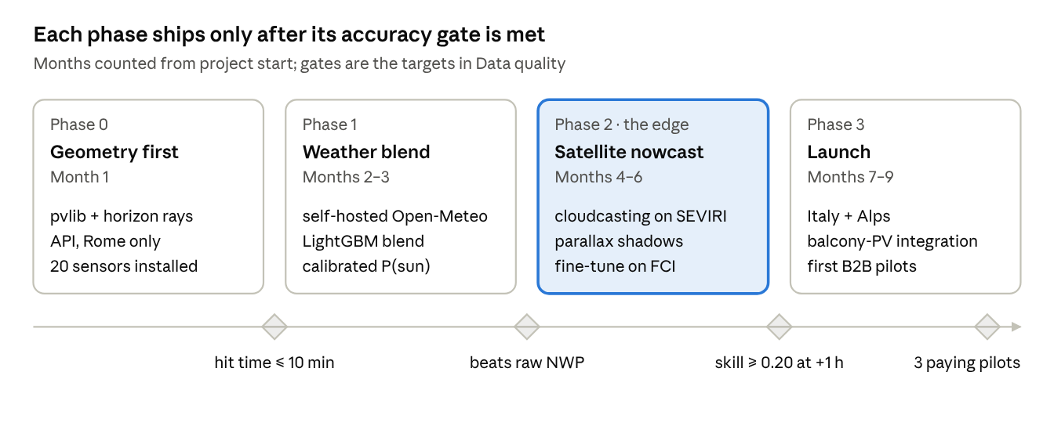
roadmap · 4 phases over 9 months, 4 accuracy gates
Geometry comes first because it is exact and cheap, and it puts sensors on balconies early: by the time the nowcast is built, months of ground truth are already waiting to train it.
The roadmap in text. Phases are numbered from 0; Phase 0 is the starting point.
Phase | Name | Months | Contains | Gate to pass before the next phase
0 | Geometry first | 1 | libs/contracts, api, PostgreSQL + PostGIS, dsm-builder on a Rome sample tile, horizon-builder, pvlib sun position, POST /v1/spots, GET /v1/spots/{id}/horizon, GET /v1/spots/{id}/windows (geometry only, p_sun omitted), GET /v1/point; order and install about 20 ESP32 light sensors in Rome; minimal debug web page | Sun-hit start/end time MAE ≤ 10 min vs sensors on modelled (uncalibrated) spots
1 | Weather blend | 2–3 | Self-hosted open-meteo with ICON-2I, ICON-EU, IFS, CAMS; truth-collector + MQTT; predictor with LightGBM blend; isotonic calibration; timeline endpoint; calibrate endpoint | Day-ahead Brier skill score ≥ 0.15 vs raw NWP cloud cover, calibration error ≤ 0.03
2 | Satellite nowcast (the edge) | 4–6 | sat-ingest, nowcast with Open Climate Fix cloudcasting on SEVIRI, cloud-shadow parallax correction, fine-tuning on MTG FCI, trainer + MLflow, notifier + webhooks | Brier skill score ≥ 0.20 at +1 h vs smart persistence
3 | Launch | 7–9 | Coverage Italy + Alps, balcony-PV integration (OpenDTU / Home Assistant), reference consumer app, monitoring dashboards | 3 paying B2B pilots

Risks and open questions
The biggest technical risk is the nowcast: the open models were trained on SEVIRI, and MTG FCI imagery differs enough that they must be retrained before minute-level claims hold.
Risk | Impact | Mitigation
Open cloudcasting models trained on SEVIRI, not FCI | Nowcast accuracy below target on new imagery | Start on SEVIRI (available until at least end 2026), fine-tune on FCI as history accumulates
Satellite-derived building heights off by several metres | Sun-hit times wrong by several minutes in dense streets | National LiDAR where open, OSM heights, and user calibration overriding the model
Too little ground truth early on | Blending model cannot learn or prove itself | Own 20-sensor network in Rome from week 1; recruit balcony-PV owners in Home Assistant communities
AGPL license of Open-Meteo | Obligations if modified and offered as a network service | Run it unmodified as an internal service; confirm with a lawyer
Shadowmap or a weather company adds cloud nowcasting | The gap closes | Speed plus the ground-truth dataset, which competitors cannot download
GPU and storage costs grow with coverage | Margin pressure beyond Italy | Expand region by region, only where paying customers exist
Open questions:
- ☐ Which ARPA regional networks publish pyranometer data openly and in near real time?
- ☐ Is Italian national LiDAR (Ministero dell'Ambiente) usable commercially, and at what coverage?
- ☐ First paying customer segment: balcony-PV owners, terrace venues, or real-estate portals?
- ☐ EUMETSAT data policy for commercial redistribution of derived products — confirm in writing.

Build decisions for implementation
These answer the questions an implementer needs before writing code; where a fact about the machine is unknown, the default below applies until confirmed.
1. Where to start: Phase 0, geometry only. Build libs/contracts, api, PostgreSQL + PostGIS, dsm-builder (Rome tile), horizon-builder and the spots / horizon / windows / point endpoints. No GPU, no satellite data, no ML. The windows response omits p_sun until Phase 1.
2. Dev environment. Windows 11, Docker Desktop on the WSL2 backend, new git monorepo (the layout in Infrastructure).
- Run the code inside WSL2 (Ubuntu), not on the Windows filesystem: GDAL and Numba builds are smoother and bind mounts are faster.
- No GPU is assumed locally: nowcast gets a stub that returns "no cloud" masks with the real output schema, behind an interface so the real model drops in on the GPU server.
- A docker-compose.dev.yml override runs only the Phase 0 services.
3. Data during development. Small samples only, downloaded by a script (scripts/fetch-samples):
- A Rome tile of about 10 × 10 km around the centre: Copernicus DEM GLO-30, GlobalBuildingAtlas heights and polygons, Meta/WRI canopy height, OpenStreetMap buildings.
- Full Italy data only on the server, in Phase 3.
- EUMETSAT and Copernicus accounts are not needed in Phase 0; they are needed in Phase 1 (CAMS) and Phase 2 (satellite). Credentials go in .env files that are git-ignored.
4. Horizon sources are pluggable. Each source (DEM, buildings, canopy, LiDAR, user calibration) implements one interface returning a height raster plus a quality score; the fused surface uses the highest-quality source per pixel. National LiDAR or ARPA data can be added later without changing the builder.
5. Auth and rate limits.
- B2B and developer access: API keys, sent as Authorization: Bearer sk_live_…; only a SHA-256 hash is stored in PostgreSQL; each key has a plan and scopes.
- Rate limits: @fastify/rate-limit backed by Redis, per key, per plan (default 60 requests per minute, 10,000 per day on the free plan).
- End users of the reference app (later): JWT issued by the api after email magic-link login.
6. Reference consumer app: out of scope for Phases 0–2. In Phase 0 only a minimal debug web page (React + MapLibre GL) to place a spot on the map and see its horizon plot and sun windows. The real consumer app comes in Phase 3 as React Native (Expo), focused on balcony-PV owners.
7. Ranges, made consistent. The nowcast covers 0–3 h everywhere. The timeline endpoint takes an hours parameter, default 72, maximum 168 (7 days); beyond 72 h it returns hourly steps instead of minutes.
8. Open questions stay open. ARPA data, LiDAR licensing, first customer segment and EUMETSAT redistribution policy remain unresolved; design around them (pluggable sources, no hard dependency) rather than deciding them in code.
Code conventions.
- TypeScript services: Node.js 22, Fastify, BullMQ, Zod schemas generated from libs/contracts JSON Schema, Vitest.
- Python services: Python 3.12, uv for dependencies, pvlib, rasterio, Numba, pytest.
- All times in UTC internally; the API converts to the spot's timezone in responses.
- Every service exposes /health and Prometheus /metrics.

Sources
- Open Climate Fix + Alan Turing Institute — cloudcasting models (Hugging Face)
- cloudcasting documentation
- EUMETSAT — MTG transition and SEVIRI continuity
- NVIDIA Earth2Studio — MTG FCI data source
- Open-Meteo — self-hosting guide
- Open-Meteo — ItaliaMeteo ICON-2I
- GlobalBuildingAtlas (ESSD, 2025)
- Land & Carbon Lab — Global Tree Canopy Height

